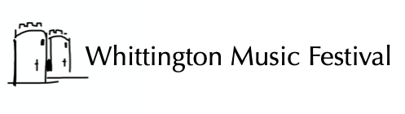
Honorary Patron Steven Isserlis CBE
Artistic Director Sophia Rahman
Supporter Scheme
Annual subscription and benefits 2024
Friends (Individual) From £35 annually or £3 monthly
Friends (Couple) From £50 annually or £4.50 monthly
- Early booking (no limit of tickets)
- Invitation to festival launch party
- Complimentary programme
- Invitation to attend rehearsals
- Optional listing on website

Benefactor (Individual) From £250 annually or £21 monthly
Benefactor (Couple) From £400 annually or £33:50 monthly
As above plus:
- Optional listing in programme
- Invitation to drinks with musicians

Sponsor (Individual) Half Concert from £500 annually or £42 monthly
Sponsor (Individual) Full Concert from £1000 annually or £84 monthly
As above plus:
- Two free tickets for any concert

Sponsor (Business) Half Concert from £500
Sponsor (Business) Full Concert from £1000
As above, plus:
- Logo on all printed publicity & website
- Free advertising in programme

For details, please ring 01691 655358 or contact friendsec@whittingtonmusicfestival.org.uk
Application Form on next page

Whittington Music Festival is promoted by Whittington Music Festival (a Charitable Incorporated Organisation, No. 1168989, Registered office: Ashfield, Bronygarth, Oswestry SY10 7LY).

Supporter Scheme
APPLICATION FORM - please send to:
Pam Parish (Friends' Secretary), 53 High Fawr Avenue, Oswestry SY11 1TB
or friendsec@whittingtonmusicfestival.org.uk
Name:
Address:
Postcode: |  | Date:
Email: |  | Phone:
I wish to become or remain a Friend/ Benefactor/ Sponsor of Whittington Music Festival
(delete as appropriate)
My 2024 subscription of £ (please complete)
*has been transferred by BACS to “Whittington Music Festival”
Sort 08-92-99 A/c No 67244980 Ref FR[my surname]
*is by cheque enclosed made out to “Whittington Music Festival”
*please delete as appropriate

If you prefer to pay monthly, please contact the Friends’ Secretary before setting up a standing order.

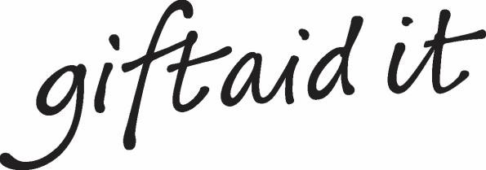

Boost your donation by £2.50 of Gift Aid for every £10 you donate
Gift Aid is reclaimed by the charity from the tax you pay for the current tax year. Your address is needed to identify you as a current UK taxpayer.
In order to Gift Aid your donation you must tick this box ☐
I want to Gift Aid my donation of £ subscription amount and any donations I make in the future or have made in the past 4 years to Whittington Music Festival.
I am a UK taxpayer and understand that if I pay less Income Tax and/or Capital Gains Tax than the amount of Gift Aid claimed on all my donations in that tax year it is my responsibility to pay any difference.
Please notify the charity if you want to cancel this declaration, change your name or home address, or no longer pay sufficient tax on your income or capital gains. If you pay Income Tax at the higher or additional rate and want to receive the additional tax relief due to you, you must include all your Gift Aid donations on your Self-Assessment tax return or ask HMRC to adjust your tax code.

